**Group of Companies**

Some of the top clients Include united phosphorus ltd., aarti organics ltd , hindalco

industries limited , hindustan zinc Ltd and meghna colour chem mcc itself

*I'*

t

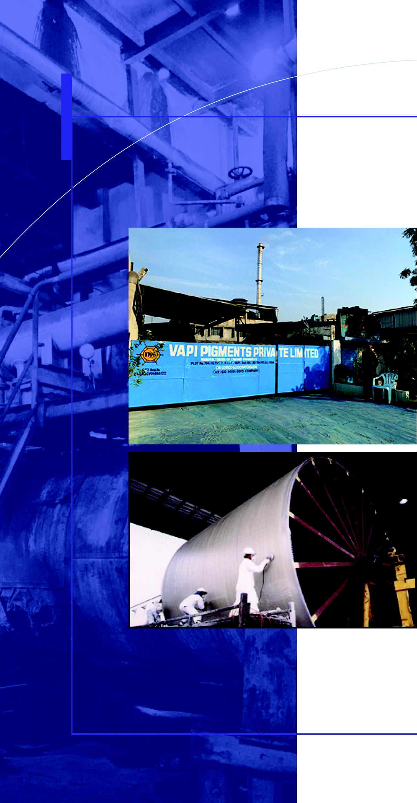

|  |  |
| --- | --- |
|  | **VAPI PIGMENTS PVT. LTD.**  AN ISO 9001:2008 COMPANY |

Vppl is one of the oldest pigment producers in vapi, gujarat. It is having a brand name in the market For its quality pigments and

serving many giant mncs in the paints, plastics & ink industry. It has Collaborated in the past with swiss multi national players like ciba/basf for producing pigments.

This has boosted the goodwill of the company in the pigments market. The company is pioneer in producing quality pigments which include chrome & anti corrosive Pigments, phthalocyanine pigments & it also manufactures cpc crude which is one of the core raw Materials for manufacturing phthalocyanine pigments.

**fr DEVENDER PLASTIC**

CHEMICAL EQUIPMENT

Dpce is an organization involved in designing manufacturing, fabrication and installa­tion of all Available plastic products such as pp/frp, hdpe pvc/frp, cpvc/frp, pvdf/frp etc and composites. Its Product range includes chemical process equipment's, pressure vessels vacuume recivers pipeline Air pollution handling equipment's including blower scrubber ducting hoods, etc it is serving Many top chemical industries in the indian market and exports as well.

